**Dobbs v. Jackson Anniversary Toolkit**

**What was Dobbs v. Jackson Women’s Health Organization?**

On June 24, 2022, the Supreme Court issued a decision to overturn *Roe v. Wade*, the landmark Supreme Court case that established a constitutional right to abortion. By stripping away the federal right to abortion, the Supreme Court left the issue of abortion care to be resolved by the states. This decision has been highly criticized by legal and medical experts alike, who contend that the Supreme Court’s decision questions the integrity of our institutions and endangers the health and well-being of pregnant people throughout the United States.

The Dobbs decision has empowered anti-abortion advocates to criminalize essential health care as well as the people who seek and provide such services.

**What is the Women’s Health Protection Act (WHPA)**

The Women’s Health Protection Act is federal legislation that codifies the right to abortion and prohibits any restrictions that seek to limit or impede access to abortion care. This bill empowers pregnant people to make safe, and well-informed decisions about their reproductive health without political interference.

**Why do we need WHPA?**

The Dobbs decision overturned nearly 50 years of legal precedent to dismantle abortion rights. In a 5-4 decision, the Supreme Court decided that the Constitution does not confer a right to abortion, effectively returning the decision to protect or restrict abortion rights to the states. Without federal abortion rights, women throughout the United States are losing access to life-saving care. Since the Dobbs decision, 14 states have banned abortion and many more are working to restrict access. These bans only work to increase mortality and morbidity rates among pregnant people. Ambiguous laws written by state legislators who do not have a background in medicine have prevented medical professionals from performing basic emergent care. The consequences of the Dobbs decision extend beyond reproductive health, touching upon every facet of health care.

More damaging, the threat of criminalization and reduced training capacity has influenced medical students and clinicians to seek training and job opportunities in less restrictive states. The Dobbs decision will only exacerbate workforce shortages and subsequently worsen health outcomes. Low-income, marginalized communities will suffer the most as local hospitals close labor and delivery services, and then, eventually close their doors permanently.

Abortion is an essential part of women’s health care. It cannot be separated or delineated. By criminalizing or restricting access to abortion, state legislatures are creating a human rights and public health crisis.

**Read Bill Text Here:**

<https://www.congress.gov/118/bills/hr12/BILLS-118hr12ih.pdf>

**What can you do to support the Women’s Health Protection Act?**

Urge Congress to pass the Women’s Health Protection Act.

* Find out if your elected officials support WHPA in the [House](https://www.congress.gov/bill/118th-congress/house-bill/12/cosponsors?s=1&r=2&q=%7B%22search%22%3A%5B%22Women%27s+Health+Protection+Act%22%5D%7D) and [Senate](https://www.congress.gov/bill/118th-congress/senate-bill/701/cosponsors).
* Support WHPA using this [email template](https://actforwomen.org/take-action/). (*Note: This link takes you to a third party website,* ***actforwomen.org.*** *The NWHN does not save or share any of the information you choose to input into the email template form on that site).*

For more information about legislation that seeks to expand access to reproductive health care, check out the [Network’s key bills' tracker for 2023](https://nwhn.org/key-bills23/).

**Social Media Graphics**

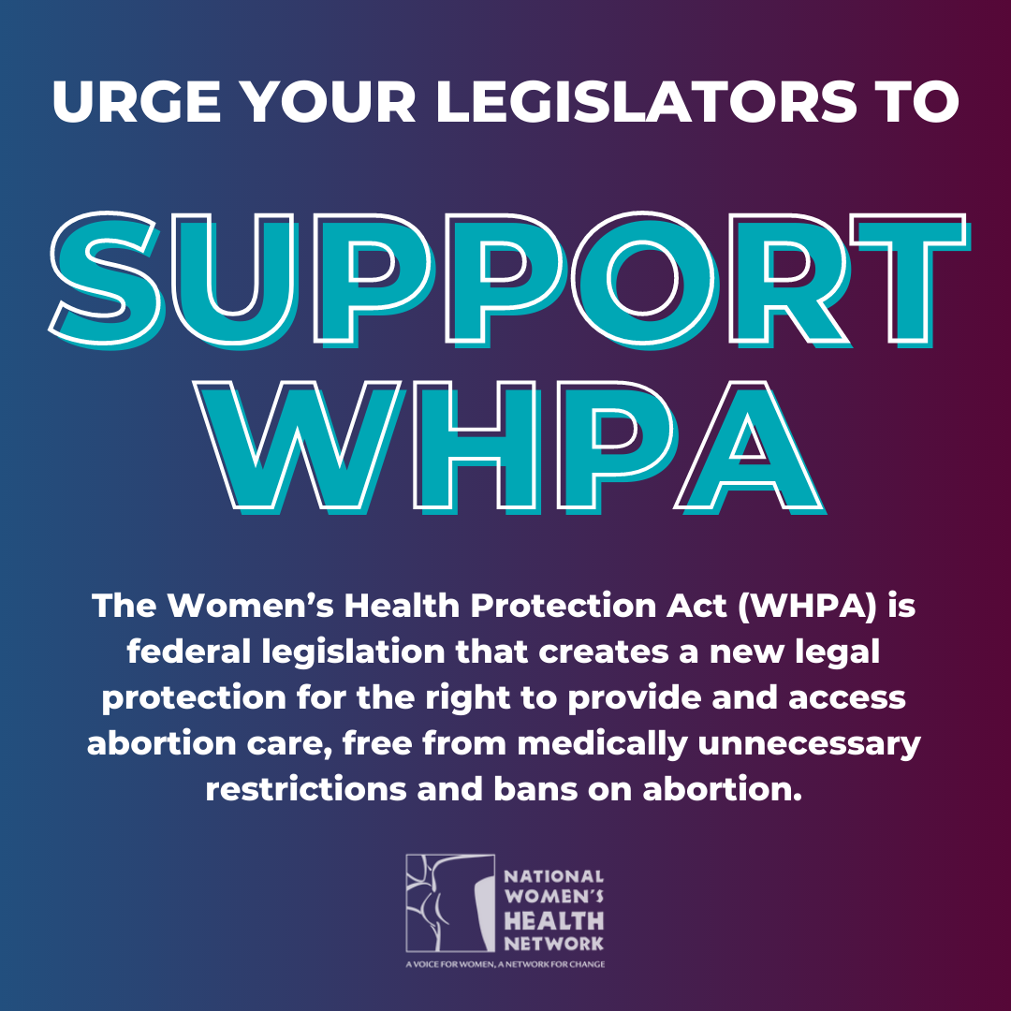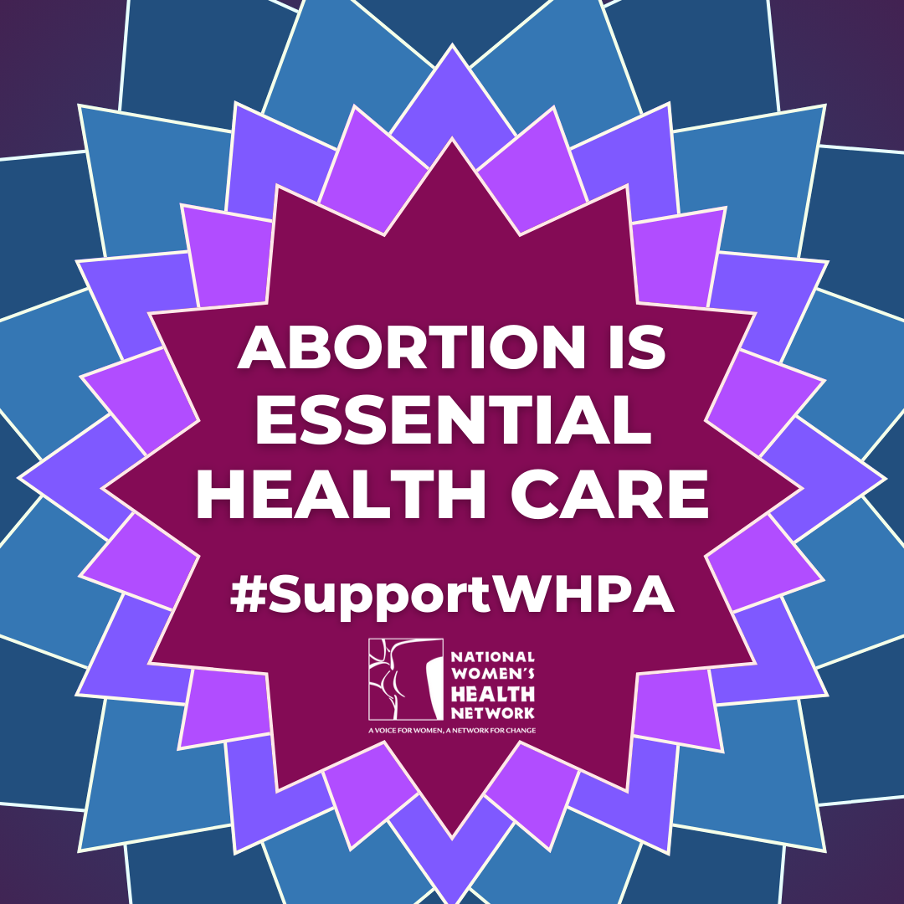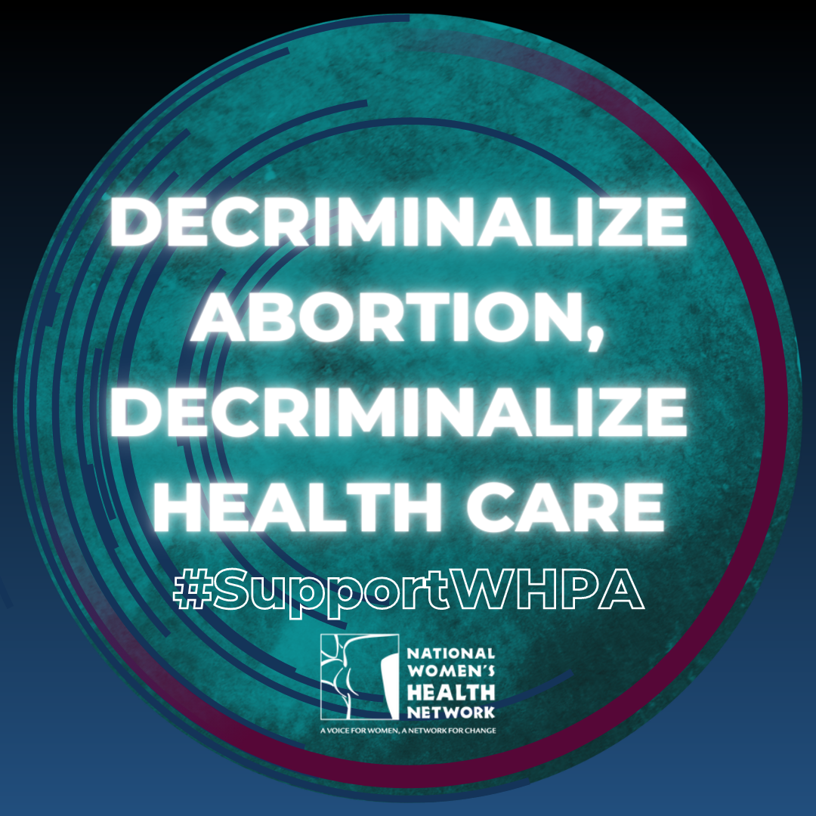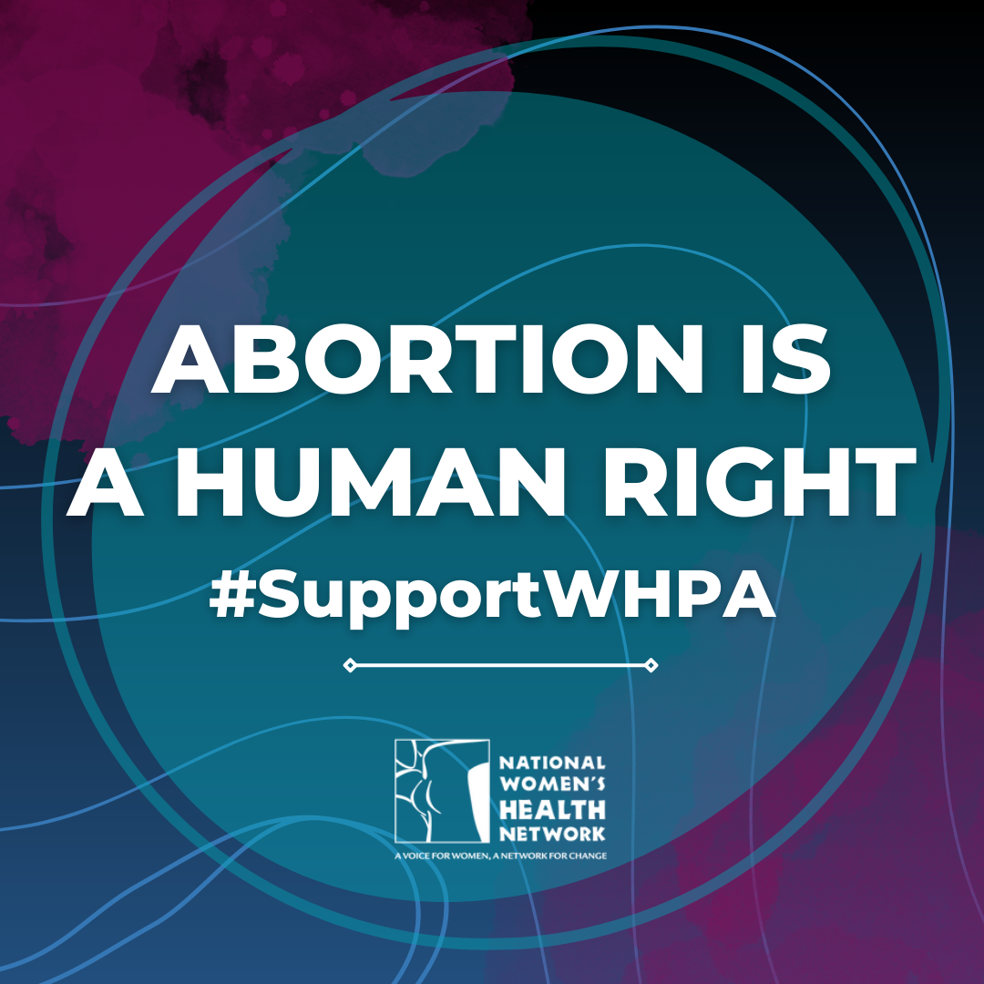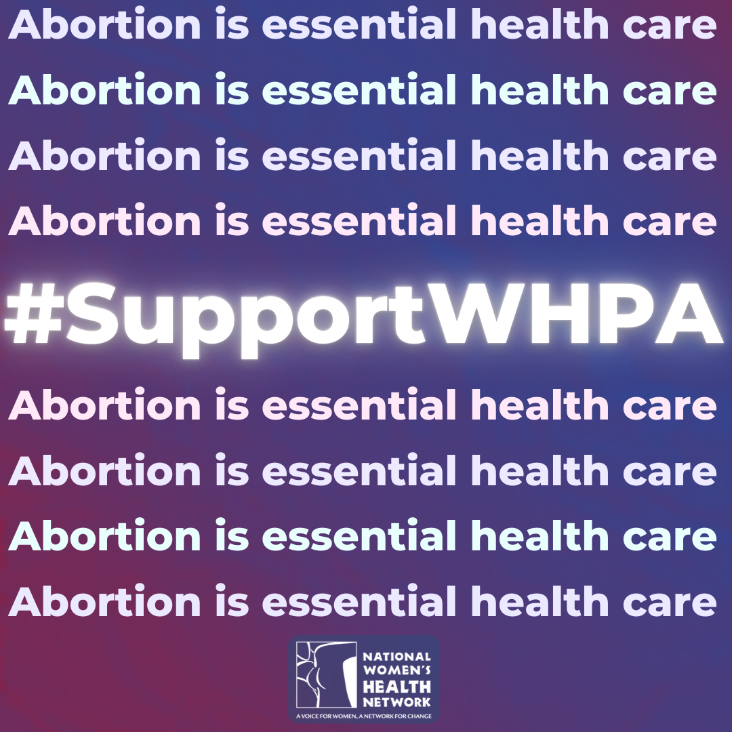

**Sample Tweets**

1. Since #SCOTUS overturned Roe v. Wade one year ago, tens of thousands of people have been denied abortion care across the country. Tell Congress to pass WHPA now to protect the right to abortion! #SupportWHPA
2. One year after #SCOTUS overturned Roe, politicians have introduced a wave of abortion bans, criminalizing access to essential health care. These discriminatory laws put pregnant people's lives at risk. Congress needs to protect abortion rights and pass #WHPA.
3. One year after the #Dobbs decision, patients are being criminalized and forced to endanger their lives to seek abortion care. Tell Congress to pass WHPA now to protect abortion access! #SupportWHPA
4. Abortion bans lead to poor health outcomes among non-pregnant and pregnant people alike. Tell Congress to pass WHPA now to protect abortion access! #SupportWHPA
5. The Dobbs decision threatens access to reproductive health care beyond abortion, such as contraception and preventative exams. Reproductive health clinics are closing rapidly amidst state bans. Tell Congress to pass WHPA now to protect abortion access! #SupportWHPA
6. The Women’s Health Protection Act (WHPA) is federal legislation that safeguards the right to abortion and bodily autonomy. Tell Congress to pass WHPA now to protect abortion access! #SupportWHPA

**Suggested Hashtags**

Primary hashtag: #SupportWHPA

Secondary Hashtags: #AbortionIsHealthcare #ReproductiveRightsAreHumanRights #abortion #abortionrights #abortionaccess #abortionjustice #dobbsvjackson #reprorights #roevwade #dobbs